List of items:

- We need to add detailed options and functionalities that we have on the original project to new UI. Can I put these anywhere or can it only be placed in certain pages?

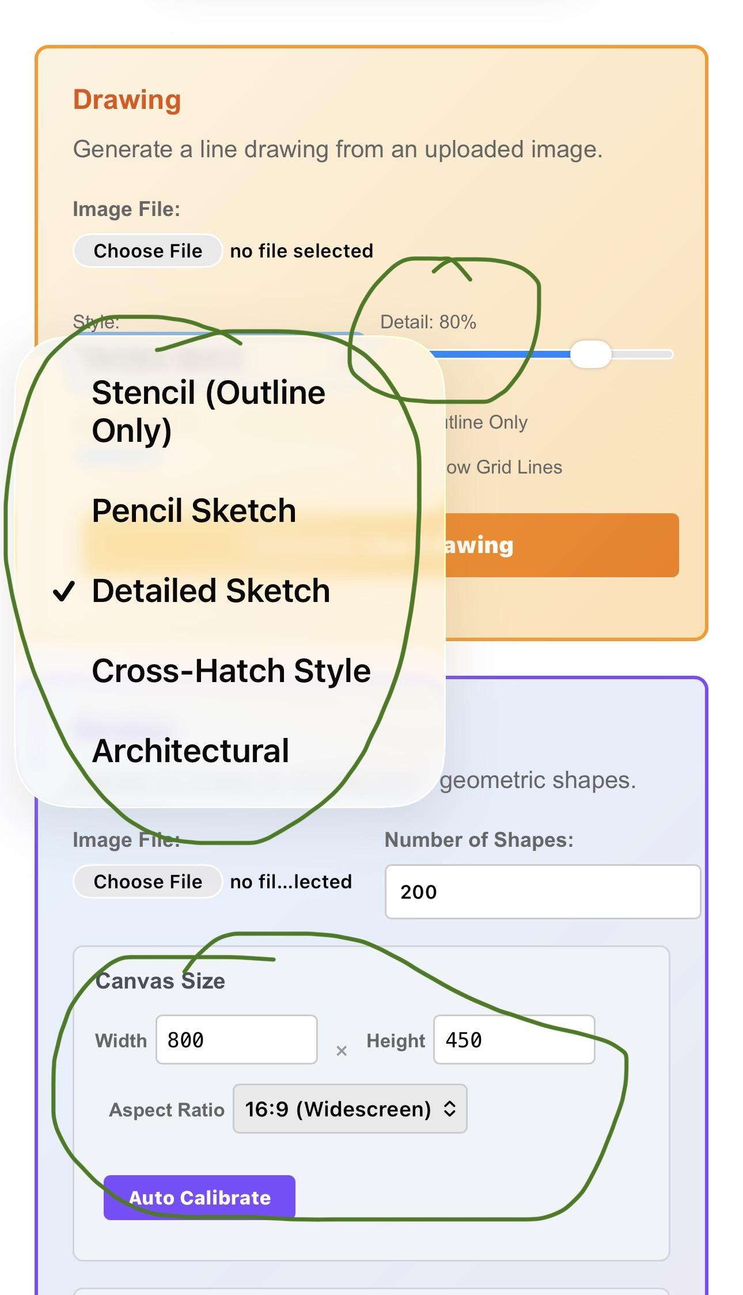
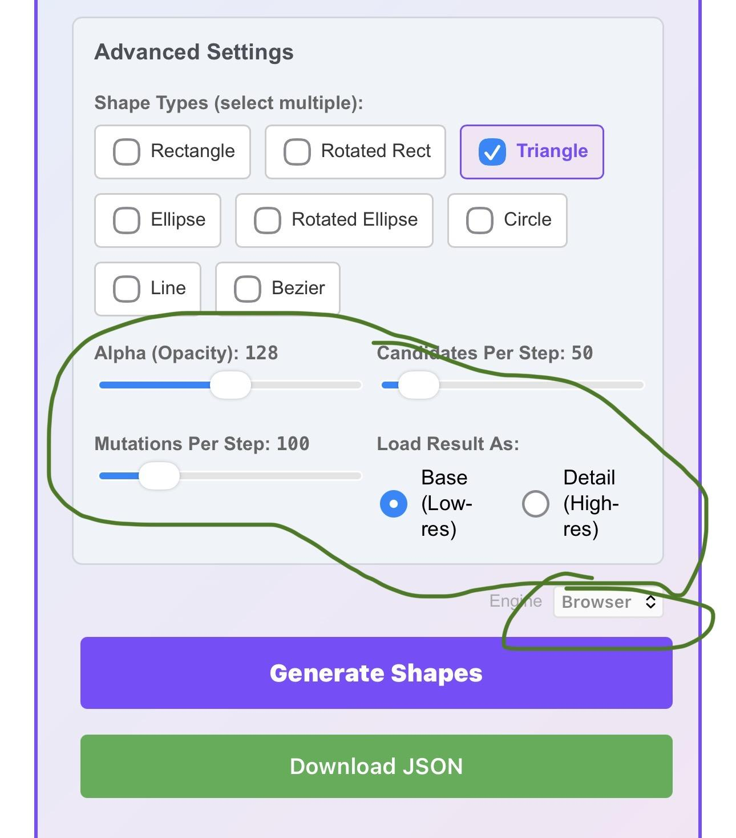

- On the page with sliders and selections, we need selective shapes. It seems to be on one icon, but do we have similar control? Like selection of region, button to trigger the selected region enhancement.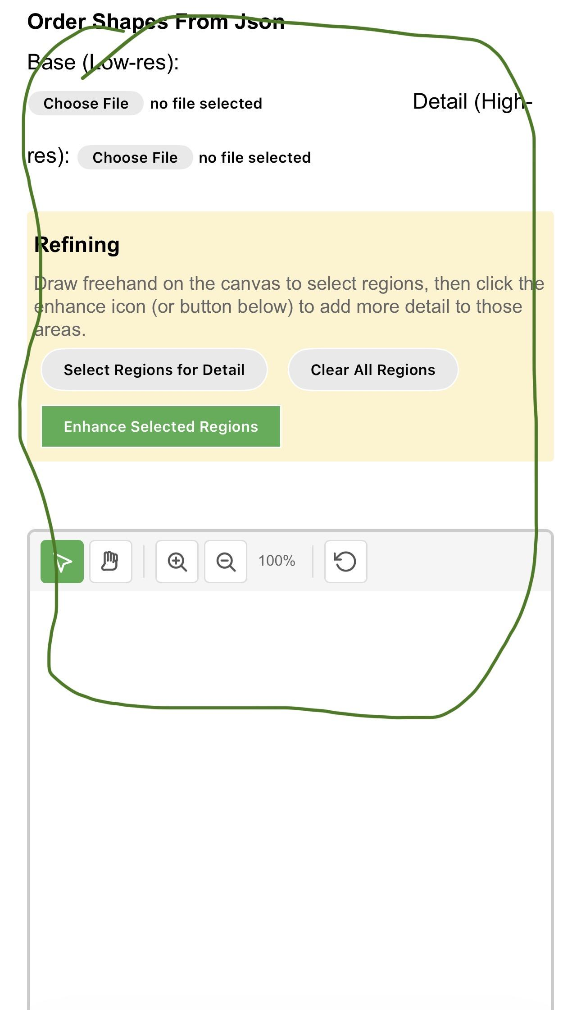
- For each of the icons, we need somewhere to click this button for fixing order:
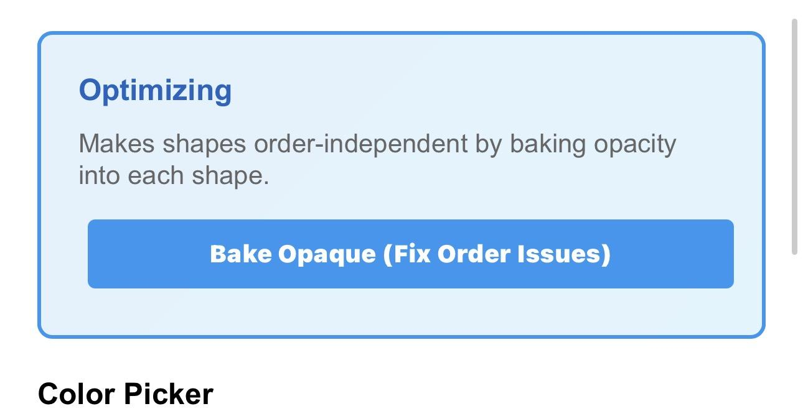

- We need newer logos on all URLs, in top left corner like https://geomagic-app.netlify.app/signin. Here is the logo: https://www.dropbox.com/scl/fi/3smdjzjvbix05hw3nudva/1.png?rlkey=b92shq8joe90n6ixrw2tm7l5e&st=f4lpp5u5&dl=0

- We need a way to stored and edit the color names and rgbs. Right now it’s hardcoded, but new ones can be added and incorporated in the unmixer of target colors:

